1. Sales Analysis Dashboard: Create a dashboard that shows sales trends over time, by region, and by product category.Use different visualizations to highlight key metrics, such as sales growth rates, top-selling products, and regional sales comparisons.

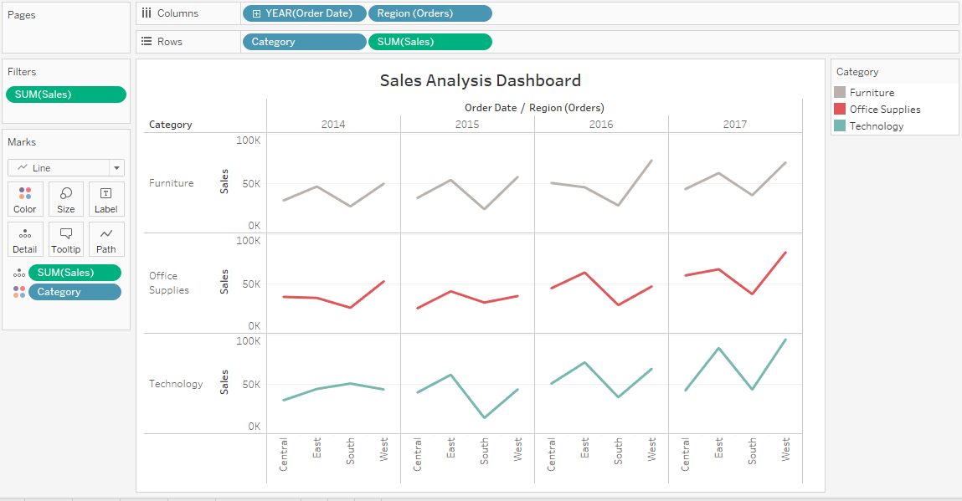

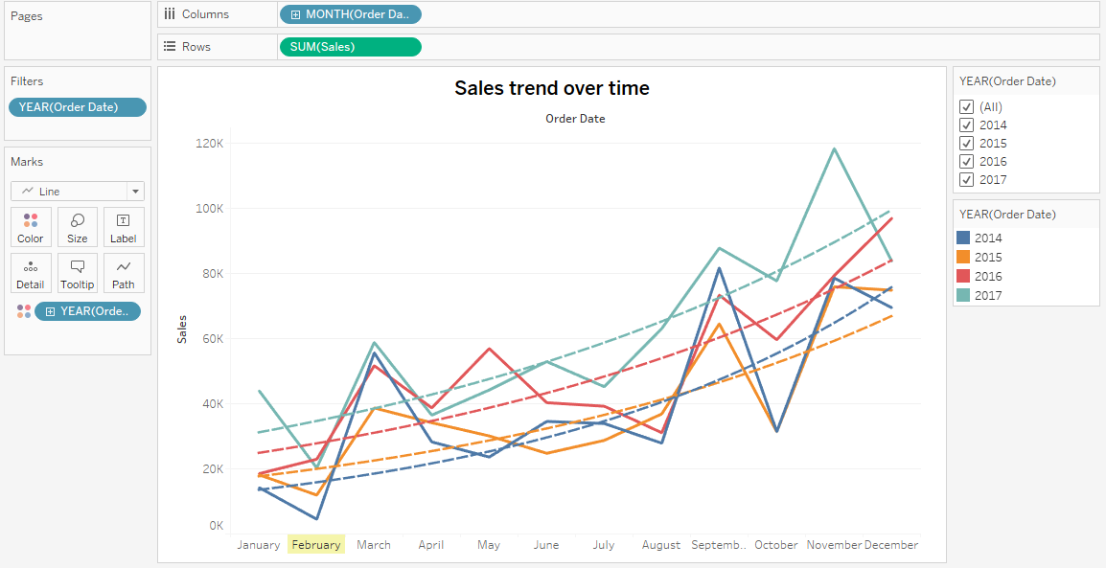

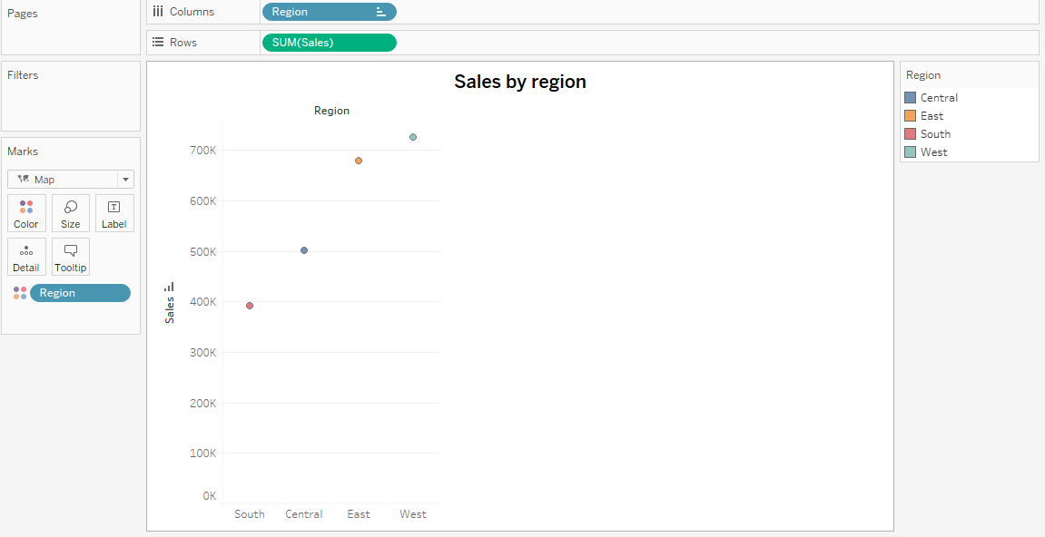

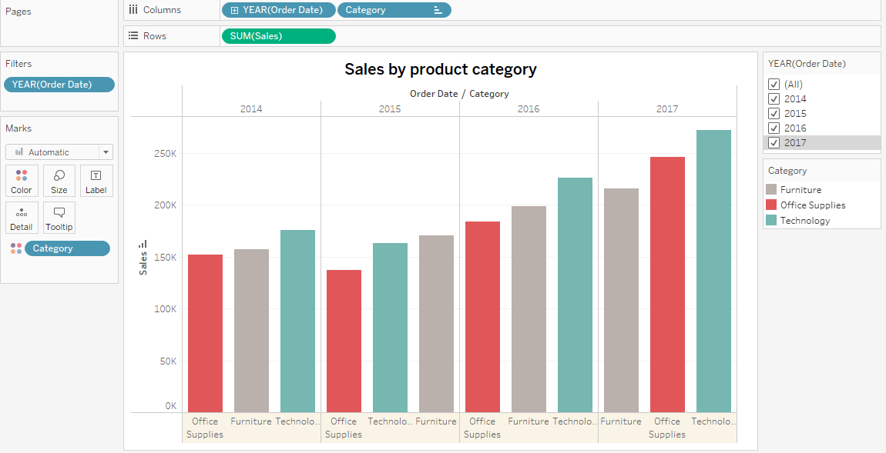

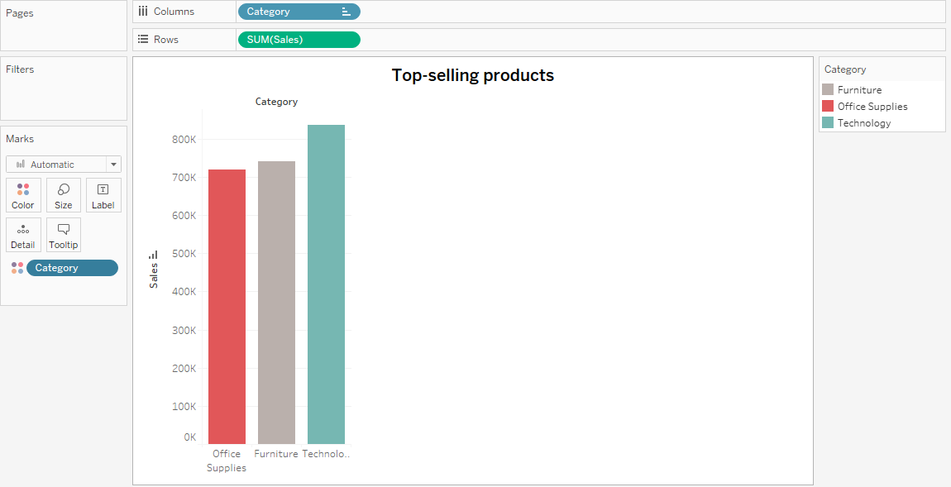

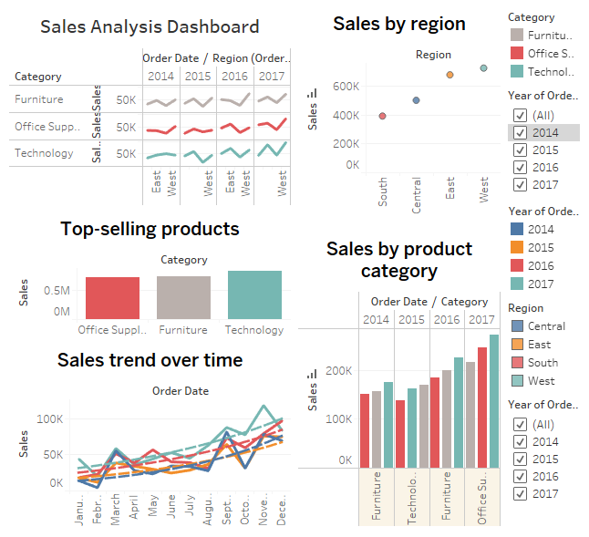

1. Customer Segmentation Analysis: Analyze customer data to identify key segments and create visualizations that show their characteristics, behaviours, and purchasing patterns. Use clustering techniques to group customers into segments, and then create visualizations that show how they differ in terms of demographics, purchasing frequency, and other factors.

